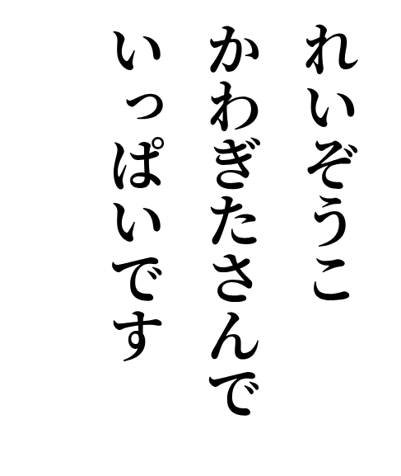

2026-09-30
Refrigerator
Refrigerator
Kawagita-san
is filed up

